**N-K-1 OEDateChange**

Logical Value = NO will not force entry of Reason Code

Logical Value = YES will force entry of Reason Code for a date change. O-U-1 UPDATE Button on Release Tab & OT1 Screen will prompt for Reason Code for the Date Change.   
Changing release date will update the User ID on the release line.

O-F-9 will house Date Change Reason Codes.  
Data example = Code = VendLate   
Description = Vendor Late on Delivery  
Data example = Code = PressCap   
Description = Press Capacity BackLog Problem

O-R-14 On Time Delivery Report Changes   
New Toggle Box: Promise Date or Release Date  
Currently report looks at BOL date versus Release Date.  
New Toggle Box = Promise Date would compare BOL Date to O-U-1 Items Tab Promise Date.  
New Toggle Box to Print Promise Date and Reason Code on Report.  
New Toggle Box to Print Percentage per Reasons Code.

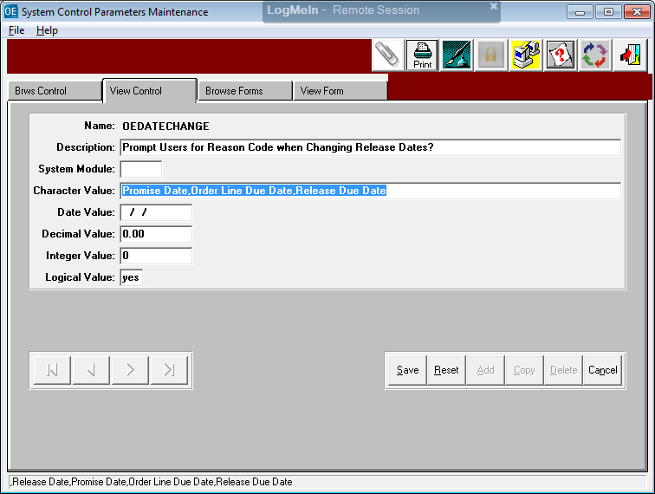

N-K-1 OEDateChg Parameter   
This will force Entry of Reason for Date Change

Check Box on O-U-1 Release Tab will show the Date and Notes for date changes of a release.

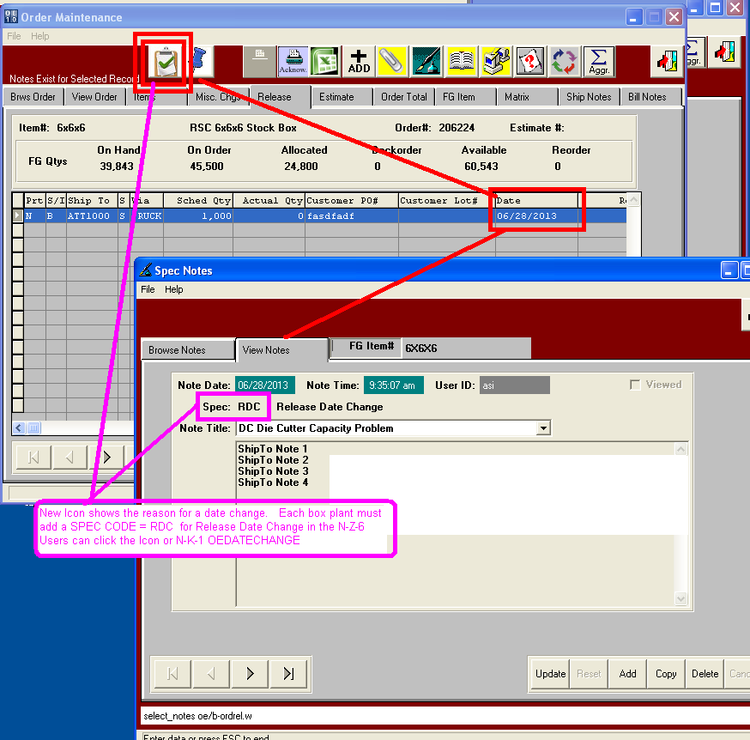

Security can be set in the Network Administration Program Master

Program Master security program = OEDateChg.r is used for security by Group or User ID for the Update Button on the Order’s Release Tab. If a user updates Date of Release, the program will prompt for Reason Code. Their User ID or user group must exist in Program Master.

